mUTAL rECOGNISATION AGREEMENTS/EXEMPTIONS

what is a Mutual Recognition Agreement?
The NASBA/AICPA International Qualifications Appraisal Board (IQAB) is the link between the U.S. accounting profession and that of other General Agreement on Trade in Services (GATS) signatory countries. Through a mutual recognition agreement (MRA), qualified professional accountants from another country can practice in the United States without having to completely re-credential. Similar recognition is given to U.S. CPAs who wish to practice in that same country.
Current Agreements
IQAB has currently established MRAs with the following professional bodies:
Institute of Chartered Accountants in Australia
Canadian Institute of Chartered Accountants
Canada, Mexico, and United States Memorandum of Understanding
Chartered Accountants Ireland (formerly the Irish Institute of Chartered Accountants)
Instituto Mexican de ContadoresPublicos
New Zealand Institute of Chartered Accountants
Hong Kong Institute of Certified Public Accountants
Any professional accountancy body wishing to enter a reciprocal agreement with U.S.-IQAB must submit a letter of intent to NASBA. The letter should contain a brief, written description of the nature and objectives of the organization, the size of its membership and its interest in applying for an MRA. If the organization does not have the authority to grant practice privileges including audit rights, it must provide evidence it can facilitate obtaining these privileges for U.S. CPAs from the licensing authority.

CPA EXAM CONTENT CHANGES

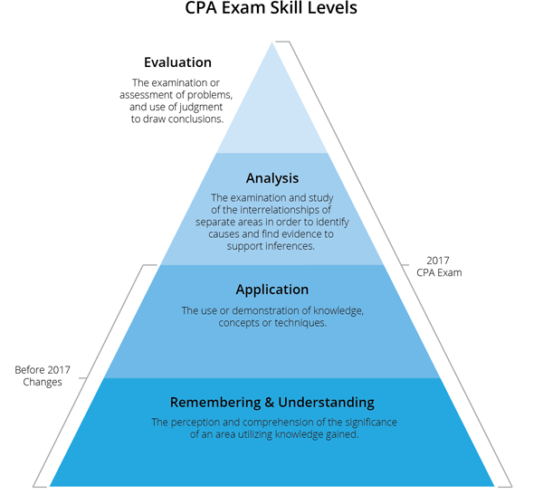
While the subject matter of the 2017 CPA Exam remains the same, the primary change to the exam is the increase in the degree - or skill level - at which that subject matter is tested.
The purpose of the CPA Exam content changes is to ensure that the CPA Exam content tests the skills that newly licensed CPAs must know to continue to protect the public interest, including:

- Critical thinking, problem solving, analytical ability, and professional skepticism
- Effective communication skills
- Well-developed research skills
- A strong understanding of the business environment and processes
- Ethics and professional responsibilities

INCREASE FOCUS ON HIGHER ORDER SKILLS
To ensure they test higher order skills, the AICPA has adopted a skill level framework based on the modified Bloom’s Taxonomy of Educational Objectives.
The previous version of the CPA Exam contained content primarily designed with the following learning framework: Remembering, Understanding, and Application. With the 2017 CPA Exam, more emphasis is on assessing higher-order skillsets: Application, Analysis, and Evaluation.
We see the assessment of higher-order skillsets within the context of questions.
- Remembering & Understanding: Identify, Classify, Recall, Explain, Categorize, Clarify, Compare, Define
- Application: Calculate, Implement, Test, Represent, Prepare, Use, Execute, Carry Out
- Analysis: Reconcile, Deconstruct, Validate, Deduce, Imply, Integrate, Distinguish, Organize
- Evaluation: Justify, Critique, Conclude, Judge, Detect, Verify, Recommend, Assess

INCREASE SKILL LEVEL TESTED ON EXAM SECTIONS
The previous version of the CPA Exam equally assesses Remembering and Understanding and Application level skills in all four exam sections. In the 2017 CPA Exam, there is a distinct shift to test higher order skills - Analysis and Evaluation – as demonstrated in the pie charts below.
AUD is the only section in the 2017 CPA Exam in which the Evaluation skill is assessed.

AUD
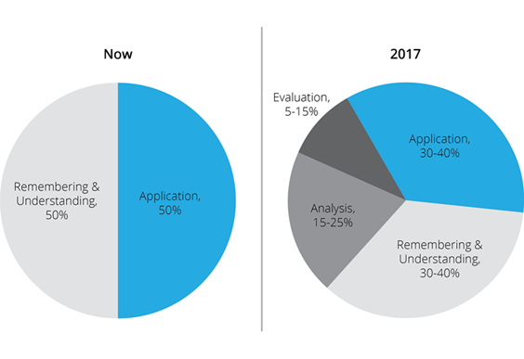

BEC
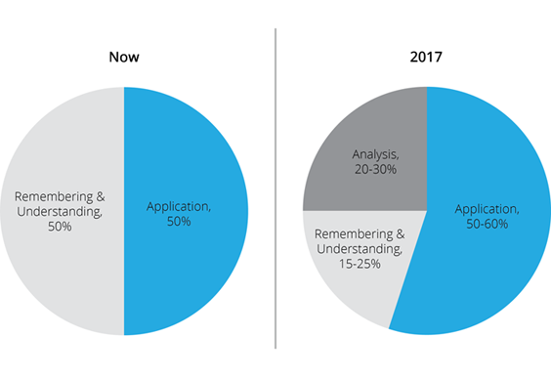

FAR
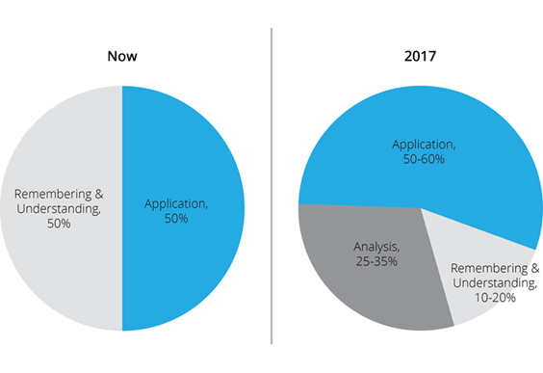

REG
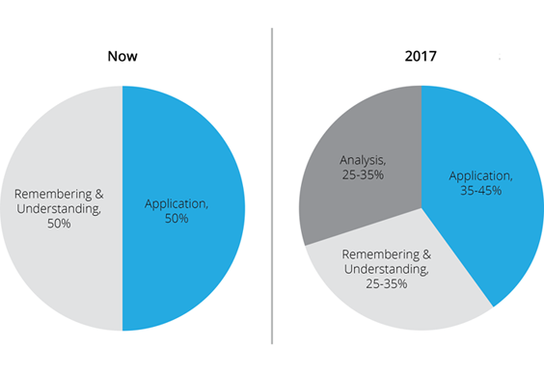

CSO VS BLUEPRINT
 | CURRENT CPA EXAM | 2017 CPA EXAM
MULTIPLE CHOICE QUESTIONS (MCQ) | Remembering & Understanding | Remembering & Understanding Application
TASK BASED SIMULATIONS (TBS) | Application | Application  Analysis  Evaluation
WRITTEN COMMUNICATION | Application | Application

CSOs – or Content Specification Outlines – are released by the AICPA each year to identify the extent of the technical content to be tested on each of the four sections of the CPA Exam.
With the 2017 CPA Exam changes, the AICPA replaced CSOs with Blueprints. According to the AICPA, the purpose of the blueprint is to:
- Provide assurance that the Exam is properly designed to test such knowledge, skills and tasks.
- Assist candidates in preparing for the Exam by delineating the knowledge and skills that may be tested.
- Apprise educators about the knowledge and skills candidates will need to function as newly licensed CPAs.
- Guide the development of Exam questions

SKILL LEVELS ASSESSED BY QUESTION TYPE
The chart below shows the increased caliber of skill levels assessed by question-type for the 2017 CPA Exam.

CPA EXAM STRUCTURE CHANGES

INCREASING TASK-BASED SIMULATIONS & DECREASING MULTIPLE CHOICE QUESTIONS
The 2017 CPA Exam includes an increase in the amount of Task Based Simulations in all sections, including the addition of TBS to the BEC section. Outlined in the table below, BEC includes four to five simulations. AUD, FAR and REG each include eight to nine TBSs.
 | Multiple Choice Questions |  | Task-Based Simulations |  | Written Communication
Section | Current | 2017 | Current | 2017 | Current | 2017
AUD | 90 | 72 | 7 | 8 | - | -
BEC | 72 | 62 | - | 4 | 3 | 3
FAR | 90 | 66 | 7 | 8 | - | -
REG | 72 | 76 | 6 | 8 | - | -

On the previous version of the exam, candidates typically alloted 10 to 20 minutes on each TBS. On the 2017 CPA Exam, candidates will need to spend 15 to 30 minutes to complete each TBS, which will now also test higher order skills - Analysis and Evaluation.
While the number of TBSs increased, the number of MCQs decreased for all sections except for the REG exam, which slightly increased. This is a direct correlation to adding more TBSs to the exam since TBSs require more time to answer and will be testing higher order skills.

DOCUMENT REVIEW SIMULATIONS
The AICPA has also announced a new type of TBS called Document Review Simulation (DRS), which is tested on the AUD, REG and FAR exam sections. As of now, this is the only significant CPA Exam change that affected the exam prior to Q2 of 2017. DRSs test candidates’ Application skills, and evolve to test Evaluation and Analysis.
The purpose of these new simulation questions is to increase the authenticity of the CPA Exam by testing real-life tasks performed by CPAs. In short, candidates are required to reference documents, such as legal letters, phone conversation transcripts, and authoritative literature to discern what is and is not important.

INCREASE TIME ALLOCATION & ADJUST SCORING WEIGHTS:

 | AUD | BEC | FAR | REG
CURRENT | 60% MCQ  40% TBS | 85% MCQ  15% WC | 60% MCQ  40% TBS | 60% MCQ  40% TBS
2017 | 50% MCQ  50% TBS | 50% MCQ  35% TBS  15% WC | 50% MCQ  50% TBS | 50% MCQ  50% TBS
The chart below shows the changes in question type on the 2017 CPA Exam.

SCORING
In the previous version of the CPA Exam, Multiple Choice Questions (MCQs) comprised 60% of the scoring weight in AUD, FAR and REG, with the balance of scoring weight attributed to TBSs. MCQs comprised 85% of the scoring weight in BEC, with the remaining 15% of the scoring weight attributed to Written Communication. Because of the increase in TBSs to assess higher order skills, the scoring weight of multiple choice questions and TBSs is now approximately 50 percent each in AUD, FAR and REG. BEC has a score weighting of 50% MCQs, 15% Written Communication and 35% Task Based Simulations.

TIME ALLOCATION CHANGES
The amount of time test takers receive for each section of the CPA Exam changed for the first time since 2011. Business Environments and Concepts (BEC) and Regulation (REG) sections of the CPA Exam increased by one hour to account for increased Task Based Simulations (TBS) and the higher level skills being assessed.
 | AUD | BEC | FAR | REG
CURRENT | 4 | 3 | 4 | 3
2017 | 4 | 4 | 4 | 4

Additionally, As a result of the 2017 exam’s increased focus on testing higher order skills, students received a 10-15 minute break during each exam section. The breaks don't count against candidates’ testing time, as compared to the previous exam, in which breaks counted against testing time.

15 MINUTE BREAK
The new exam includes a standardized 15-minute break in each section that doesn't count against the candidate’s time. Because the exam tests at higher skill levels, essentially requiring more brainpower, breaks were added to allow test-takers a moment to recollect themselves before continuing with the exam.

